Question 1

For this question, I first calculate the Greek option values by using the formula in the lecture note. I basically change my Black-Scholes function to calculate each values.

Then, I write the binomial tree model for American option price without dividends. Here is my function and my result.

文本



Then, I write the binomial tree model for American option price with dividends. Since with dividend is more complex than without dividends, I first calculate by myself on the paper, then I write code to transfer my idea into code.



Then, I compare the option price under different situation

Question 2

For this question, I used the same idea from last week. First, I calculate the implied volatility.

图形用户界面

Then, I simulate price for each portfolio. I set my simulate size as 5000.

Then, I calculate the empirical VaR and CVaR for each strategy.

图形用户界面

Also, I calculate VaR and CVaR using Delta-normal

表格

Question 3

Following the instruction, I divide 100 for each factor value to change percentage to the value. And I combine the 3 factors data with momentum data.

Then, I change daily return’s data to int64 type to easily merge two dataframe.

Then, applied the formula in the lecture note, I calculate the parameters for each stocks.



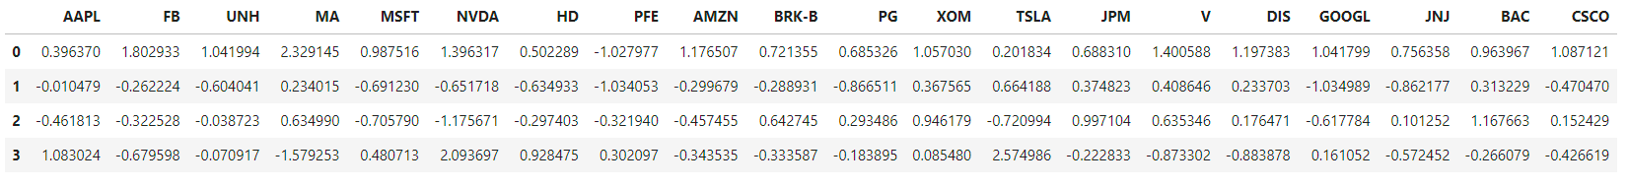

After I get the parameter’s value, I can calculate daily returns for each stock in the past 10 years.

After I get the daily return, I need to calculate the annual rate of return by using geometric returns.

First, I add a Year columns to the dataframe to split each years.

Second, I applied geometric return formula to calculate the annual return.

应用程序, 表格

Applied covariance function to find annual covariance matrix for the 20 stocks

电脑萤幕画面

For the last part,

